Q-1. What is software? What is software engineering?
->Software is a collection of programs, data, and instructions that tell a computer what to do.
In simple terms, software is the non-physical part of a computer system (unlike hardware, which you can touch).

Examples:
- Operating systems (Windows, Linux, macOS)
- Applications (MS Word, Chrome, WhatsApp)
- Games and mobile apps
Software Engineering is the systematic and disciplined approach to developing, designing, testing, and maintaining software.
It applies engineering principles to software development to ensure the software is:
- Reliable
- Efficient
- Maintainable
- Scalable

Q-2. Explain types of software.
-> 1)System Software
System software is responsible for running and controlling the computer hardware. It provides a platform for other software to work.

Examples:
- Operating Systems (Windows, Linux, macOS)
- Device Drivers (printer driver, keyboard driver)
- Utility programs (disk cleanup, antivirus)
2)Application Software
Application software is designed to help users perform specific tasks.

Examples:
- MS Word (document writing)
- Excel (calculations)
- Web browsers (Chrome)
- Mobile apps (WhatsApp, Instagram)

Types:
- General-purpose (Word, Excel)
- Specific-purpose (banking software, billing systems)
3)Programming Software
Programming software provides tools to write, test, and debug programs.

Examples:
- Compilers (C Compiler)
- Interpreters (Python Interpreter)
- IDEs (Eclipse, VS Code)
4)Utility Software
Utility software helps in maintaining and optimizing the system.

Examples:
- Antivirus software
- Disk cleanup tools
- Backup software
- File compression tools (WinRAR)
5)Embedded Software
Embedded software is built into hardware devices to control their functions.

Examples:
- Software in washing machines
- Microwave ovens
- Cars (engine control system)

Q-3. What is SDLC? Explain each phase of SDLC
SDLC (Software Development Life Cycle) is a step-by-step process used to develop high-quality software in a systematic way.

It ensures that software is:
- Well planned
- Properly tested
- Delivered on time
- Easy to maintain
In simple terms:
SDLC = A structured process to build software from start to end
Phases of SDLC:
1) Requirement Gathering & Analysis:
In this phase, developers collect and understand what the user needs.
- Meet clients or users
- Identify requirements (features, functions)
- Analyze feasibility
Output: Requirement Specification Document (SRS)
2) System Design:
Here, the system is planned and designed based on requirements.
- Define system architecture
- Design database, UI, modules
- Decide technologies to use
Output: Design Documents
3) Implementation:
In this phase, developers write the actual code.
- Convert design into programs
- Use programming languages (C, Java, Python)
- Develop modules
Output: Working software code

4) Testing:
The software is tested to find and fix errors (bugs).
- Unit testing
- Integration testing
- System testing
Goal: Ensure software works correctly and meets requirements

5) Deployment:
The software is released to users.
- Install software in real environment
- Make it available to customers
Example: Launching an app on Play Store

6) Maintenance:
After deployment, software is updated and improved.
- Fix bugs
- Add new features
- Improve performance
This phase continues as long as software is used

Q-4. What is DFD? Create a DFD diagram on Flipkart
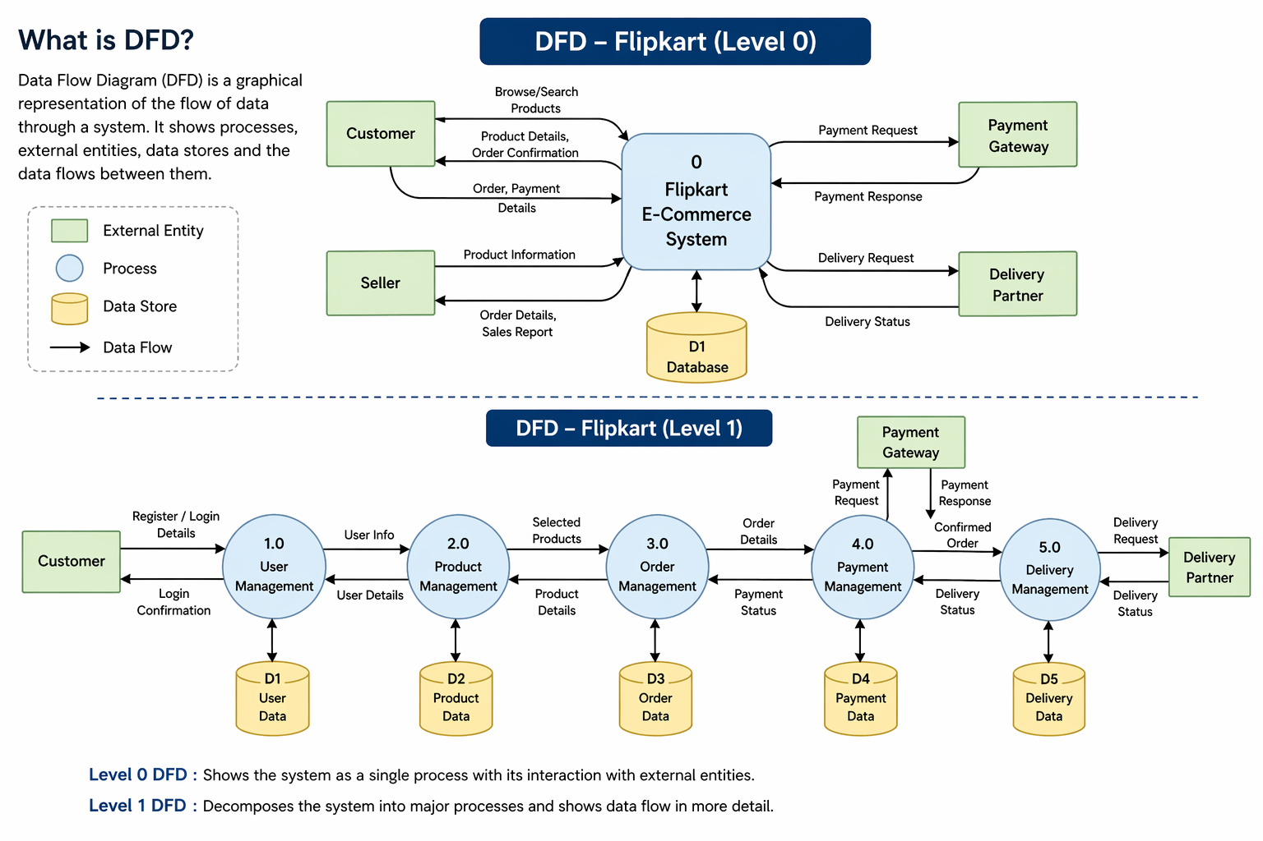
Q-5. What is Flow chart? Create a flowchart to make addition of two numbers
A flowchart is a graphical representation of an algorithm or process.
It uses standard symbols and arrows to show:
- The sequence of steps
- The flow of control in a program or system
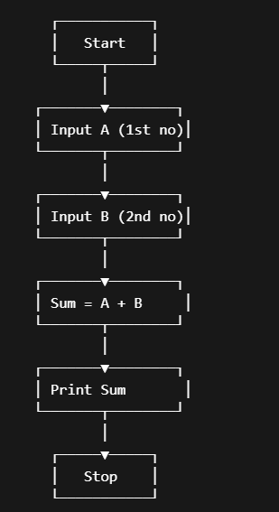
Q-6. What is Use case Diagram? Create a use-case on bill payment on paytm.
A Use Case Diagram is a type of diagram in UML (Unified Modeling Language) that shows how users (actors) interact with a system.
